Data Sheet
Product Information
Product Name |  |  | : | Recombinant human Platelet-Derived Growth Factor(rhPDGF-BB)
Synonyms |  |  | : | SIS, SSV, PDGF2, c-sis, PDGF-BB. platelet derived growth factor subunit B
Description |  |  | : | PDGF-BB is a member of the platelet-derived growth factor family.. This gene product can exist either as a homodimer (PDGF-BB) or as a heterodimer with the platelet-derived growth factor alpha (PDGFA) polypeptide (PDGF-AB), where the dimers are connected by disulfide bonds. Mutations in this gene are associated with meningioma. Reciprocal translocations between chromosomes 22 and 17, at sites where this gene and that for COL1A1 are located, are associated with a particular type of skin tumor called dermatofibrosarcoma protuberans resulting from unregulated expression of growth factor. (Ref. From Wikipedia)
NCBI Accession No. |  |  | : | NM_002608.2
Amino acid sequence |  |  | : | SLGSLTIAEPAMIAECKTRTEVFEISRRLIDRTNANFLVWPPCVEVQRCSGCCNNRNVQCRPTQVQLRPVQVRKIEIVRKKPIFKKATVTLEDHLACKCETVAAARPVT*
Molecular Mass |  |  | : | 12.39 kDa (110 aa)
Protein Tags |  |  | : | No tagging
Source |  |  | : | E. coli.
Cat. No. |  |  | : | JW-H027-0010, JW-H027-0025, JW-027-0100, JW-H027-0250, JW-H027-0500, JW-H027-1000
Storage |  |  | : | Should be at ≤ -70 ℃ as undiluted aliquots of handy size. Avoid repeated freezing and thawing.
Cross Reactivity |  |  | : | Rat, Mouse
Quality Control
Test items |  |  |  |  | Specifications
Appearance |  | : |  |  |  | Clear, colorless liquid
Purity |  | : |  |  |  | Greater than 95 % by SDS-PAGE
Specificity |  | : |  |  |  | Using Western blot, detection | 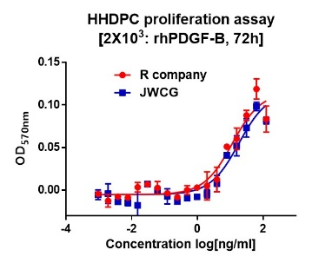
Concentration |  | : |  |  |  | 0.1 mg/㎖, Bradford method
Biological Activity |  | : |  |  |  | Determined by proliferation of HHDPC cells indicator cells. The ED50 is 1.0~6.0 ng/ml.
Endotoxin |  | : |  |  |  | Less than 0.1 EU/㎍ as determined by the LAL method
Formulation |  | : |  |  |  | 100mM Sodium acetate, 10% Glycerol (pH 5.0) without preservative or carrier proteins.
Stability |  | : |  |  |  | Stable for up to 12 months at -70 ℃. Stable for a month at 4 ℃.
Sterility |  | : |  |  |  | Sterilized through a 0.2 ㎛ membrane filter and packaged aseptically. Culture for 2 weeks, no growth

